|  |  |  |
| --- | --- | --- |
| **LAB211 Assignment** | **Type:** | **Short Assignment** |
| **Code:** | **J1.S.P0056** |
| **LOC:** | **120** |
| **Slot(s):** | **1** |

**Title**

   Program to manage worker information.

**Background**

N/A

**Program Specifications**

Create a program to manage worker:

1. Add a Worker.
2. Increase salary for worker.
3. Decrease for worker.
4. Show adjusted salary worker information.

***Function details:***

**Function 1:** Display a menu and ask users to select an option.

* Users run the program. The program prompts users to select an option.
* Users select an option, perform **Function** **2**.

**Function 2:** Perform function based on the selected option.

* Option  1: Add an worker
  + Prompt user to input task information (id, name, age, salary, work location)
  + Check data input is valid with following information:
    - Code(id) cannot be null or duplicated with existed Code in DB.
    - Age must be in range 18 to 50
    - Salary must be greater than 0
  + Add Worker to DB.
  + Return to main screen.
* Option  2: Increase salary
  + Prompt user to input Code(id) and amount of money to raise
  + Data must be valid with following conditions
    - Code(id) must be existed in DB.
    - Amount of money must be > 0
  + Add salary to worker and save salary history
  + Return to main screen
* Option  3: Decrease salary
  + Prompt user to input Code(id) and amount of money to cut.
  + Data must be valid with following conditions
    - Code(id) must be existed in DB.
    - Amount of money must be > 0
  + Subtract salary to worker and save salary history
  + Return to main screen
* Option 4: Show all worker have been adjusted salary by worker code.
* Option 5: Quit program.

***Expectation of User interface:***

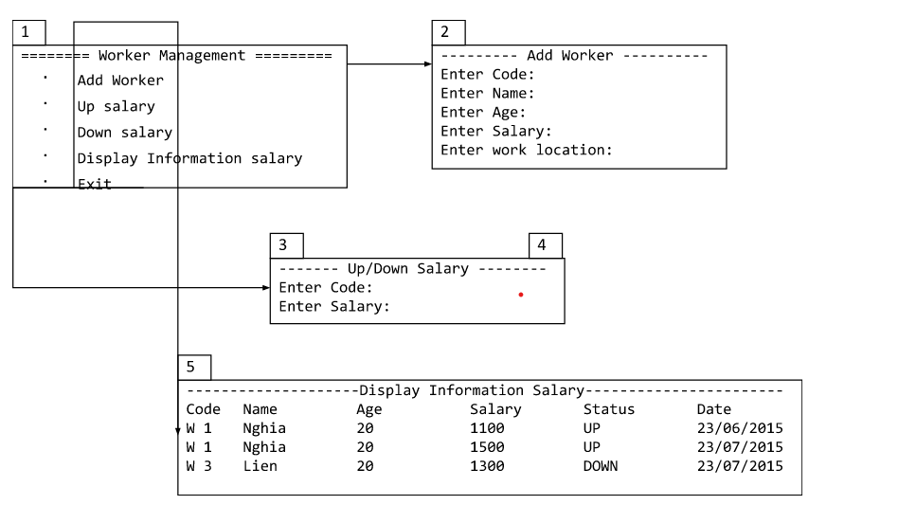

**Guidelines**

**Student must implement methods**

* addWorker
* changeSalary
* getInfomationSalary

**in startup code.**

**Example:**

Class Management contains functions add, show, increase, decrease salary of workers.

**Option** **1:** Add worker

* Named function: public boolean addWorker(Worker worker) throws Exception
* Input:
* worker: worker information.
* Return values:
* Worker added status.
* Exceptions list.

**Option** **2 & Option** **3:** Adjust salary.

* Named function: public boolean changeSalary(SalaryStatus status, String code, double amount)
* Input:
* status: is increase or decrease.
* code: code Worker
* amount: amount of money
* Return values:
* Status of adjusted.
* Exception list.

**Option** **4:** Display the list of adjusted salary workers.

* Named functions: public List<SalaryHistory> getInfomationSalary()
* Input:
* Return value: List of worker sort by id.